Meet Our Auctioneer….

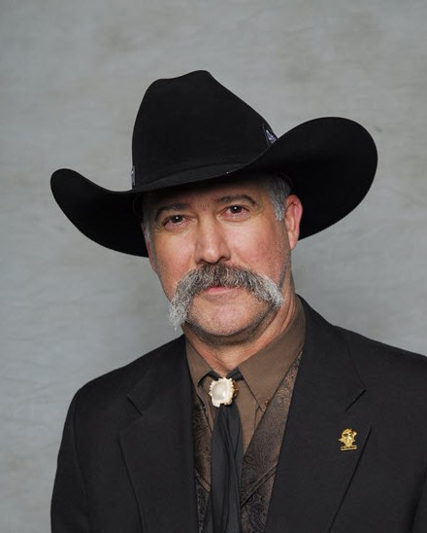
John Nelson has been a professional Auctioneer since 1981. He graduated from Western College of Auctioneering in Billings Montana, where he served as Class President.
John was raised in Montana, and graduated from the University of Montana in 1992 with a Bachelor Degree in Wildlife Biology. He and his wife, Kimberly currently reside in Salmon, Idaho with their three children.
He is an active member of the Idaho Association of Professional Auctioneers as well as the National Auctioneers Association. John has been a finalist in the Idaho Association of Professional Auctioneer’s State Champion Auctioneer Contest (2008), and is a 3-time finalist, and 2nd Runner up Northwest Champion Auctioneer (2015).
John is a life member of SCI, and has been a member of the National Auctioneering Team for Safari Club International since 2005. He served as a Professional Spotter and Floor Auctioneer from 2005-2008, and was appointed as an Auctioneer at the SCI National Hunters Convention in 2009. John continues to annually serve as an Auctioneer at the SCI International Hunters Convention in Las Vegas, Nevada.
John Nelson has served as an Auctioneer for the Grand Slam Club-Ovis National Convention in Reno, Nevada since 2014, and he and his twin brother, Rohn Nelson have both served as the Auctioneers for this prestigious, annual event in Las Vegas, Nevada since 2015.
In 2014, John Nelson was also selected as an Auctioneer at the annual Rocky Mountain Elk Foundation’s, Elk Camp and National Convention in Las Vegas, Nevada.
John and his twin brother Rohn Nelson are co-owners of Open Buckle Auction Service. They both currently serve as professional Auctioneers throughout the western United States and Alaska. You are invited to visit Open Buckle Auction Service at www.openbuckle.com.

Open Buckle Auction Service
13 Miller Lane
Salmon, ID 83467
(208) 940-1527
Email: jknelson@custertel.net
www.openbuckle.com

